**Module 5: Assignment 1: Using Node middleware ORM modules and Middleware Security Modules to implement security**

Sanket Gawade

Arizona State University

IFT 598: Middleware Programming & Database Security

Professor. Dinesh Sthapit

October 27, 2022

Install Jsonwebtoken

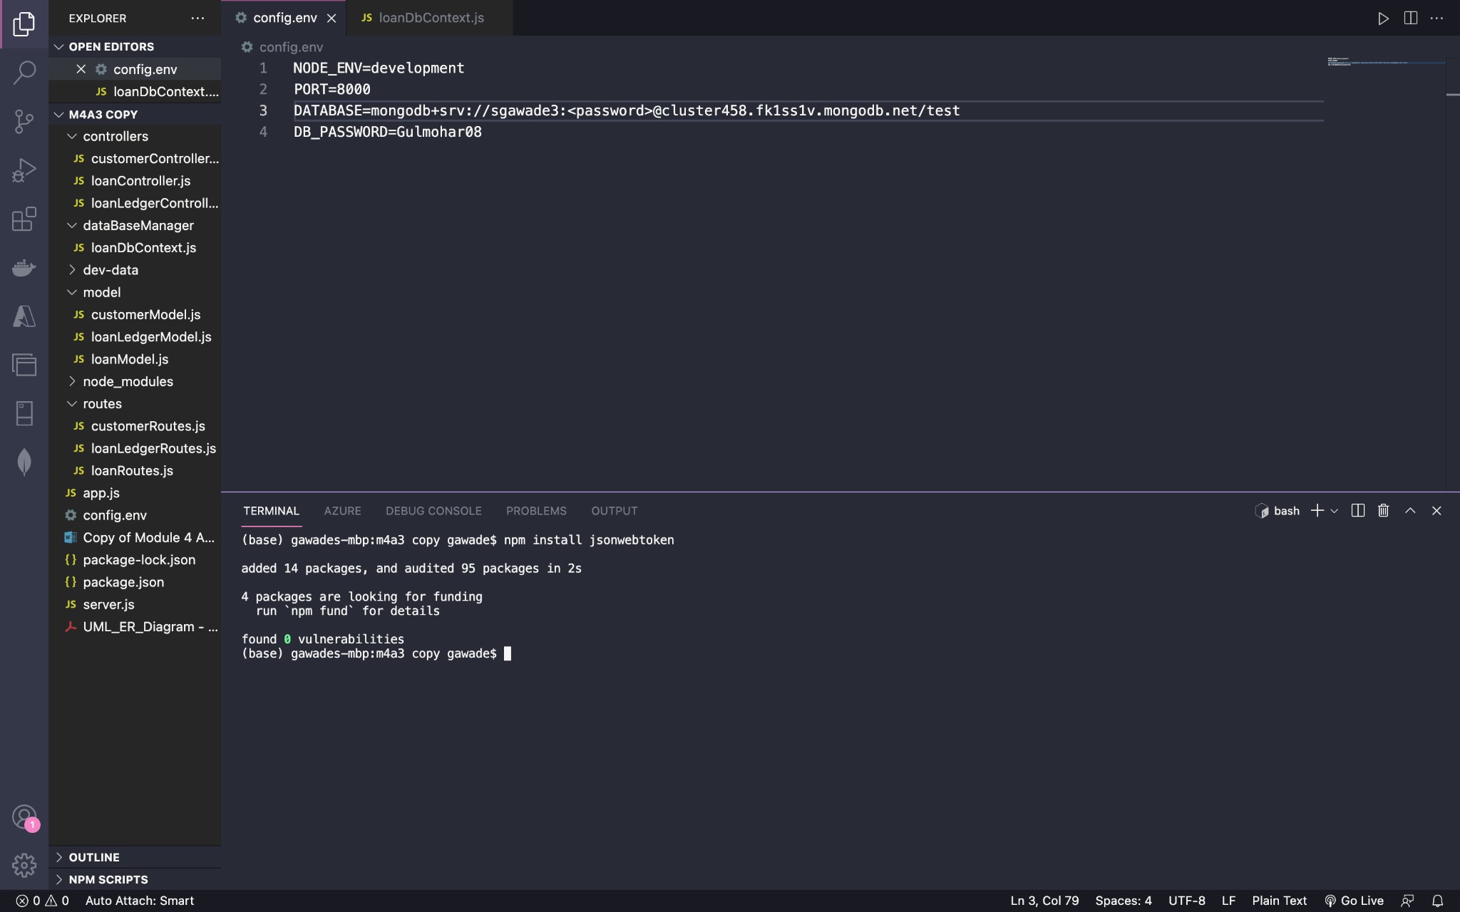

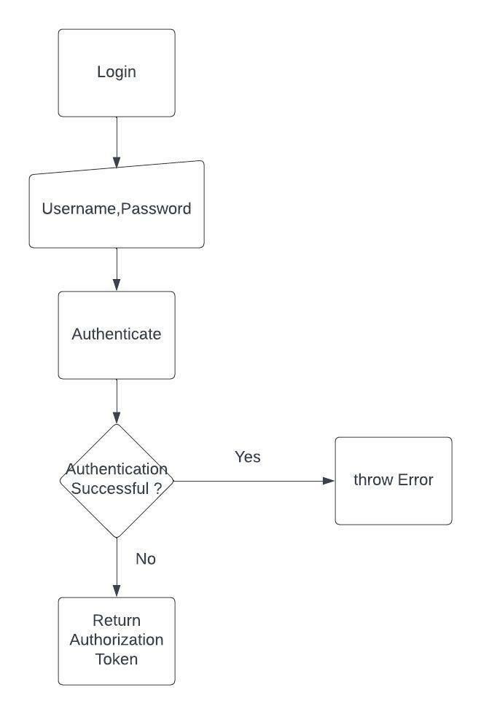

**Step 2: Create user model**

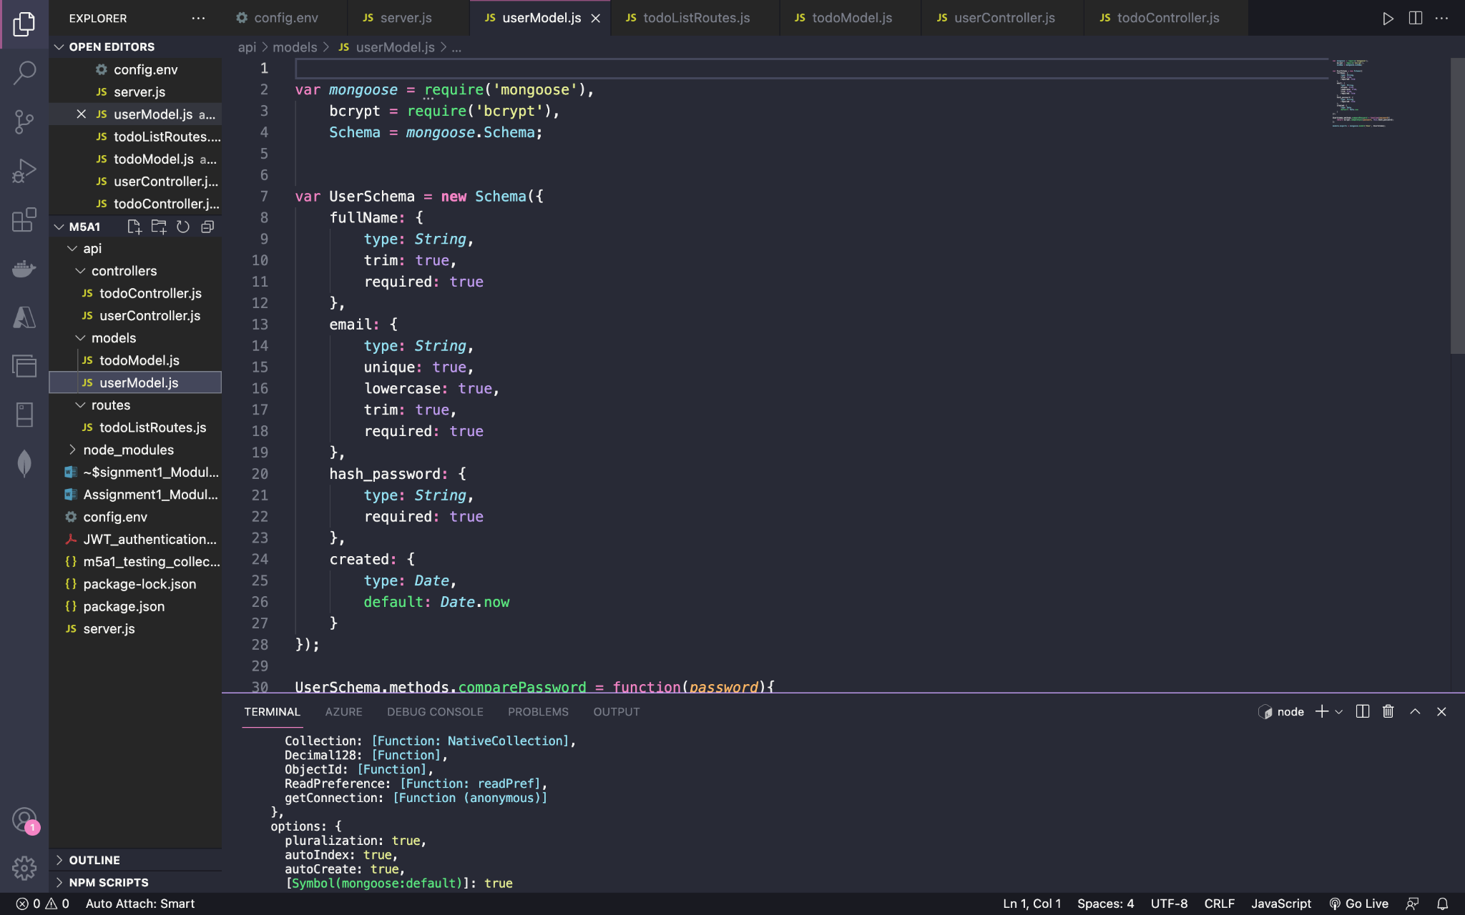

**Creating the todoModel.js in the api/models folder**

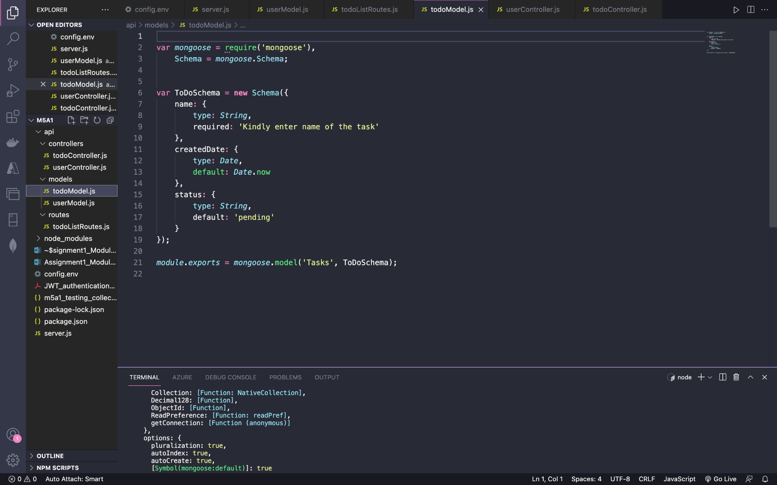

**Creating todoController.js file in api/controllers folder**

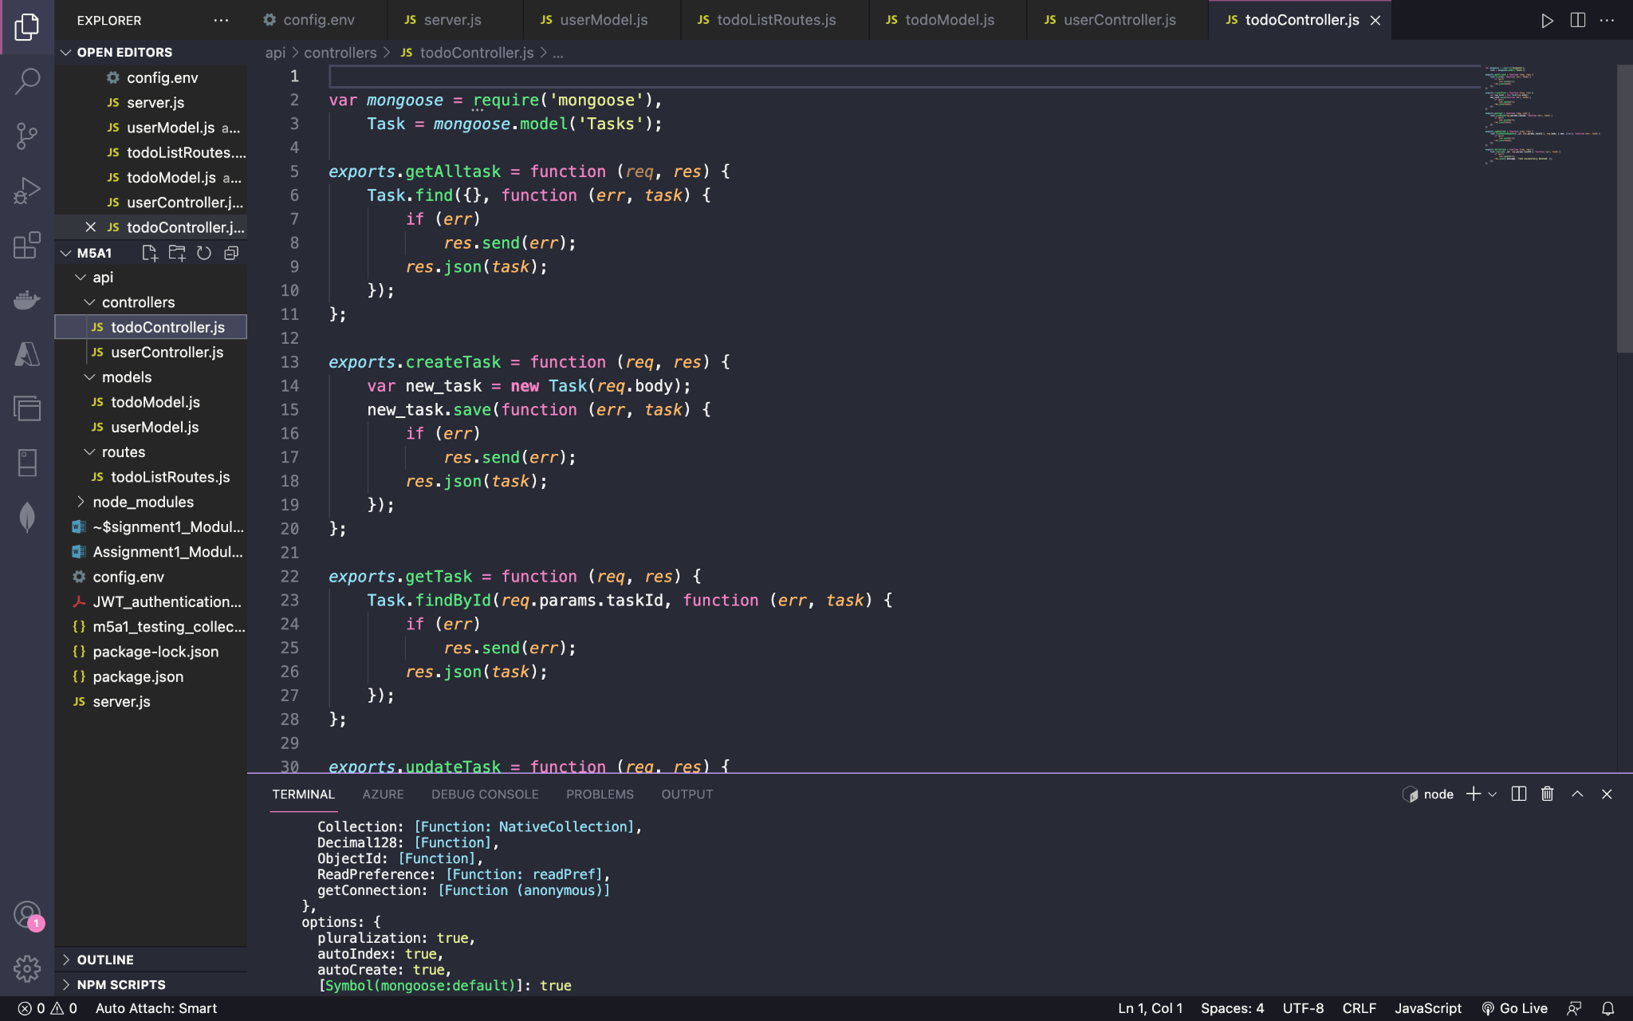

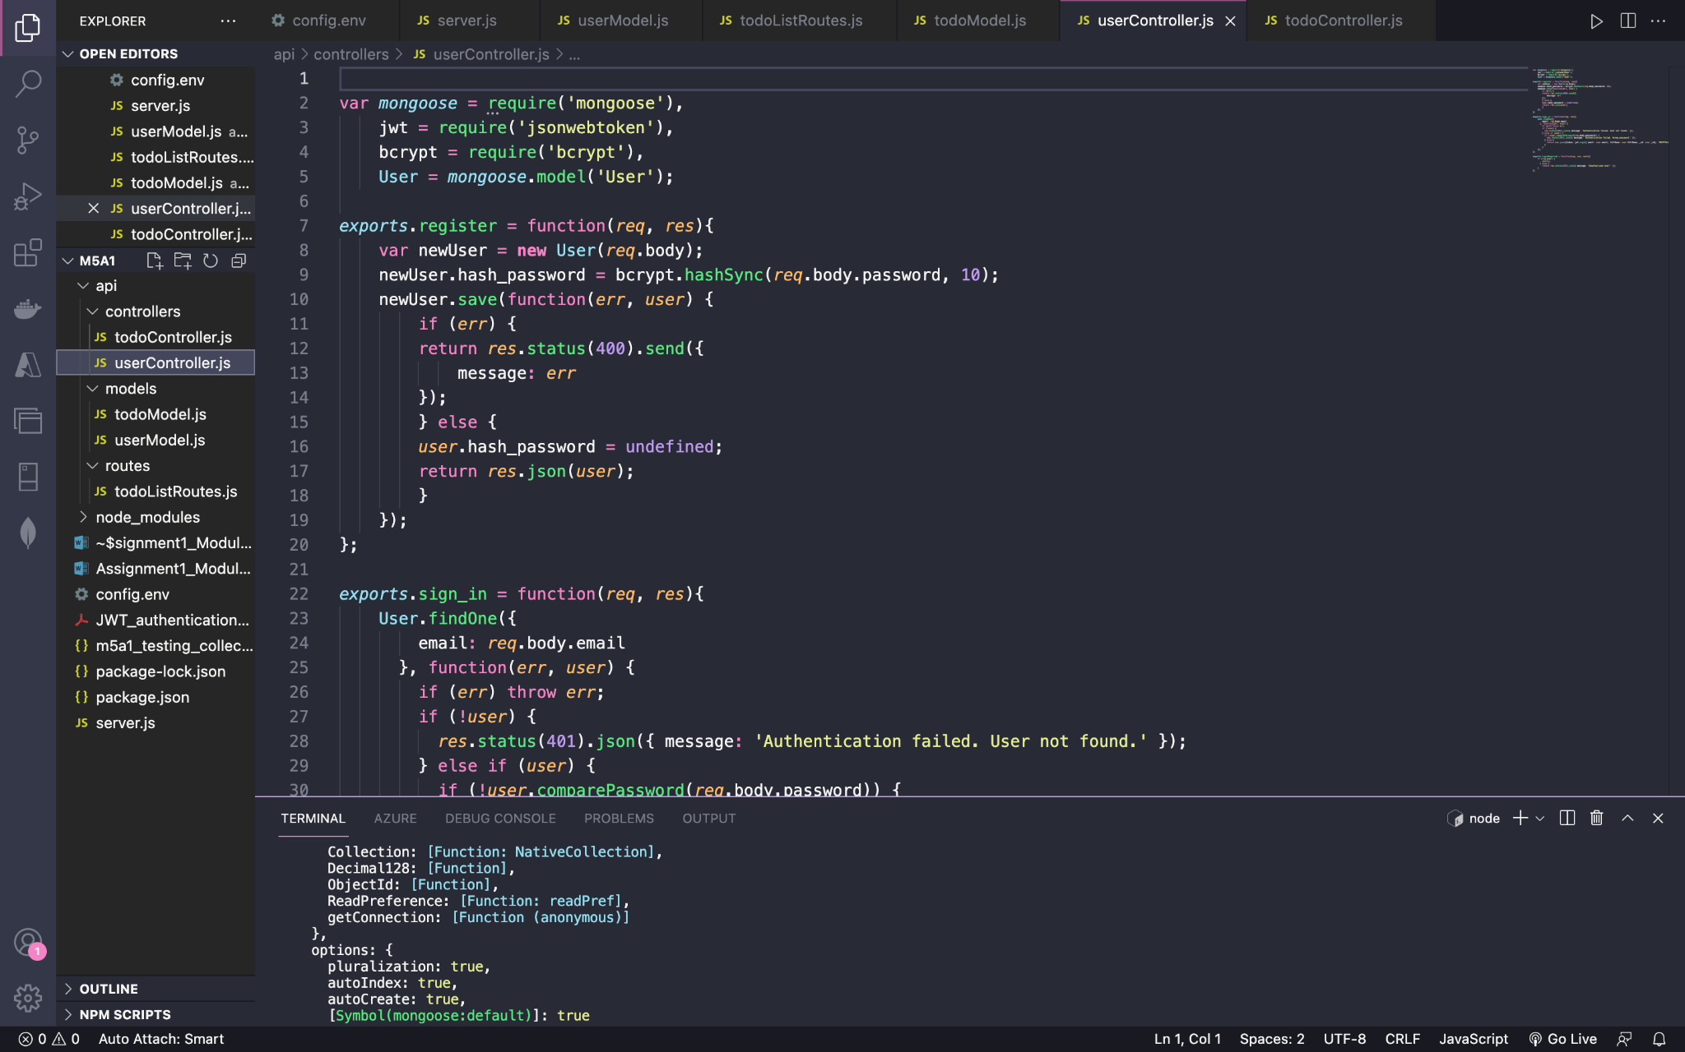

**step 4: Create the user routes and update “/tasks” route**

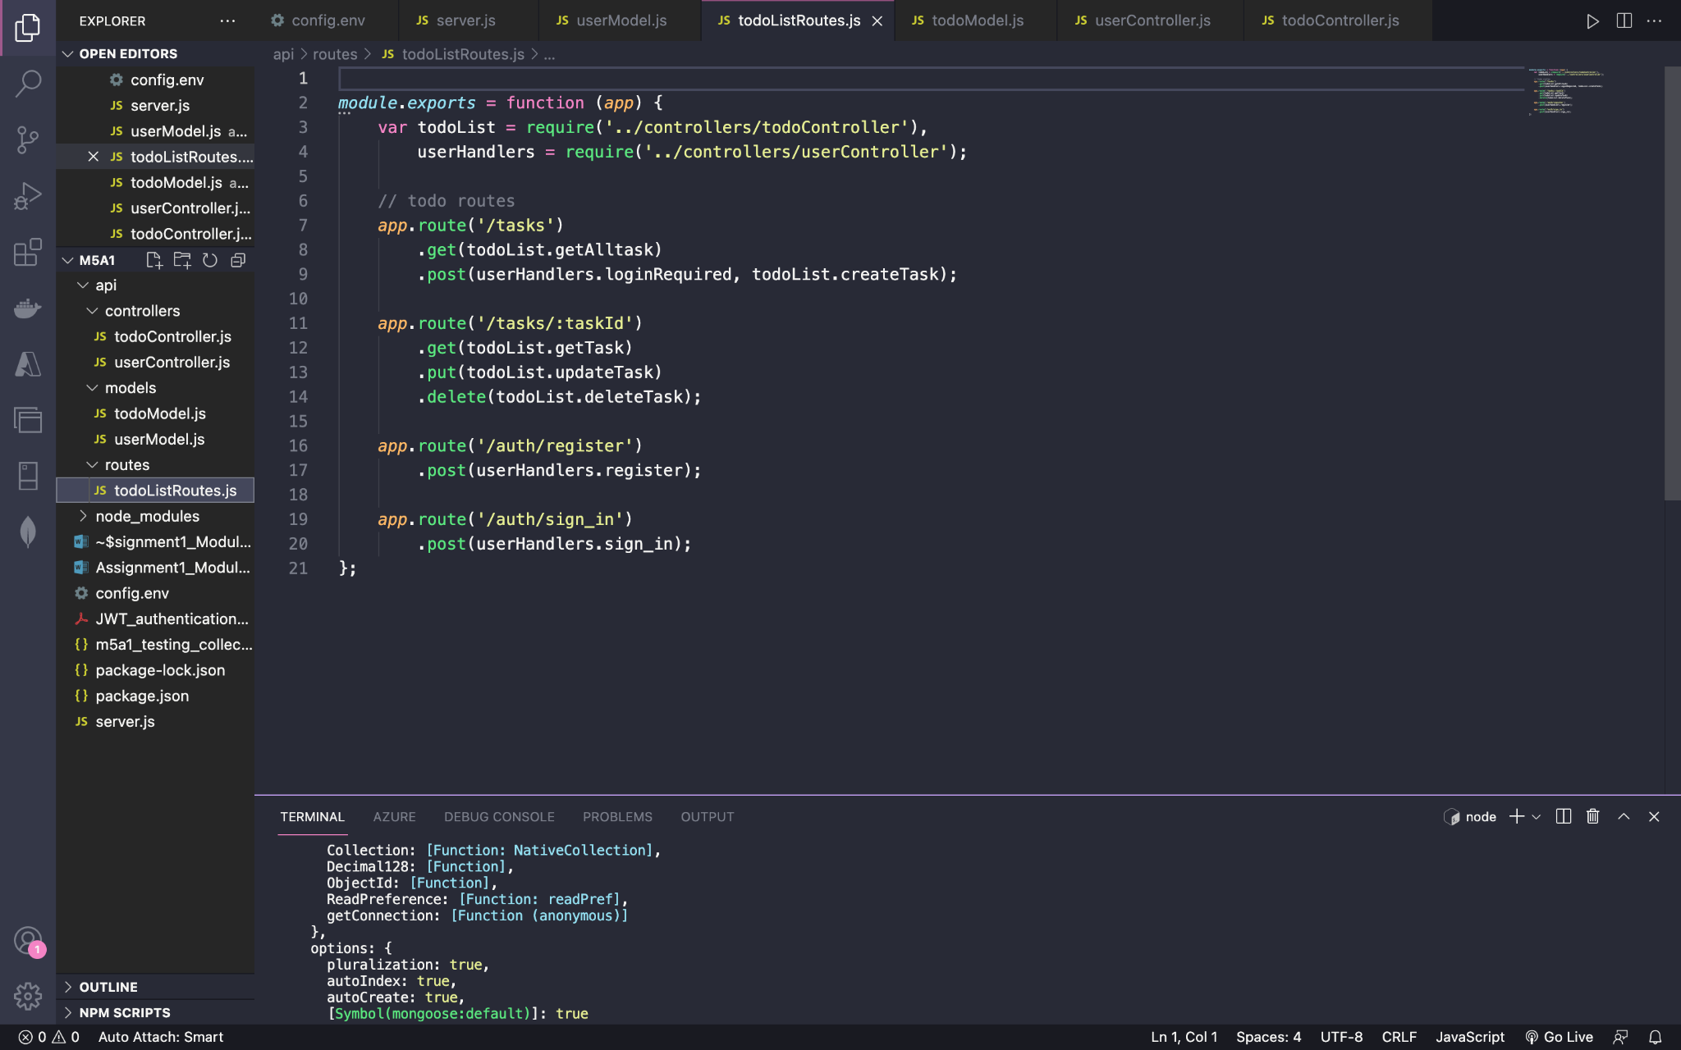

Creating server.js file in the main project folder

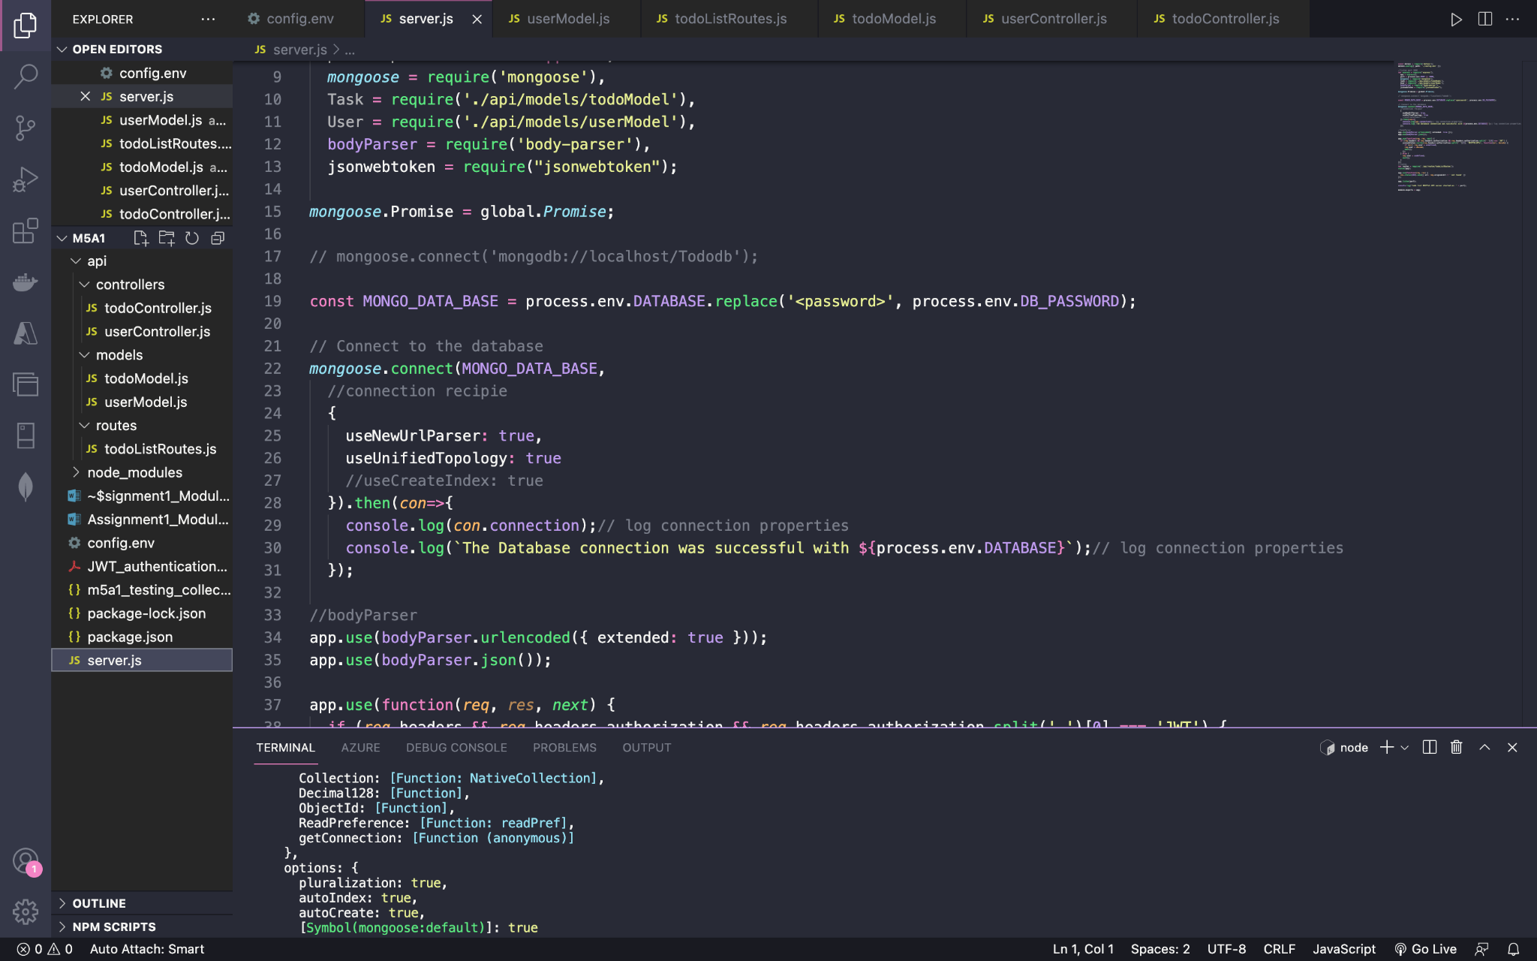

Creating the config.env file

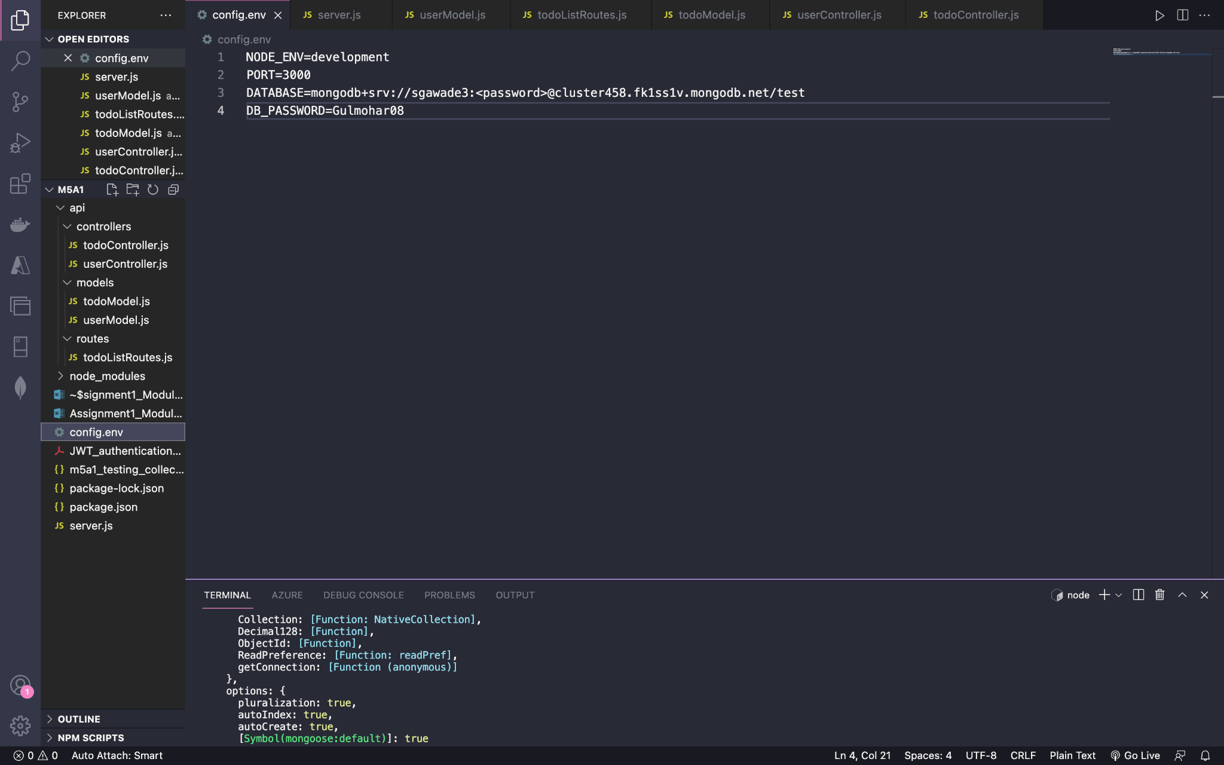

Executing the command npm run start

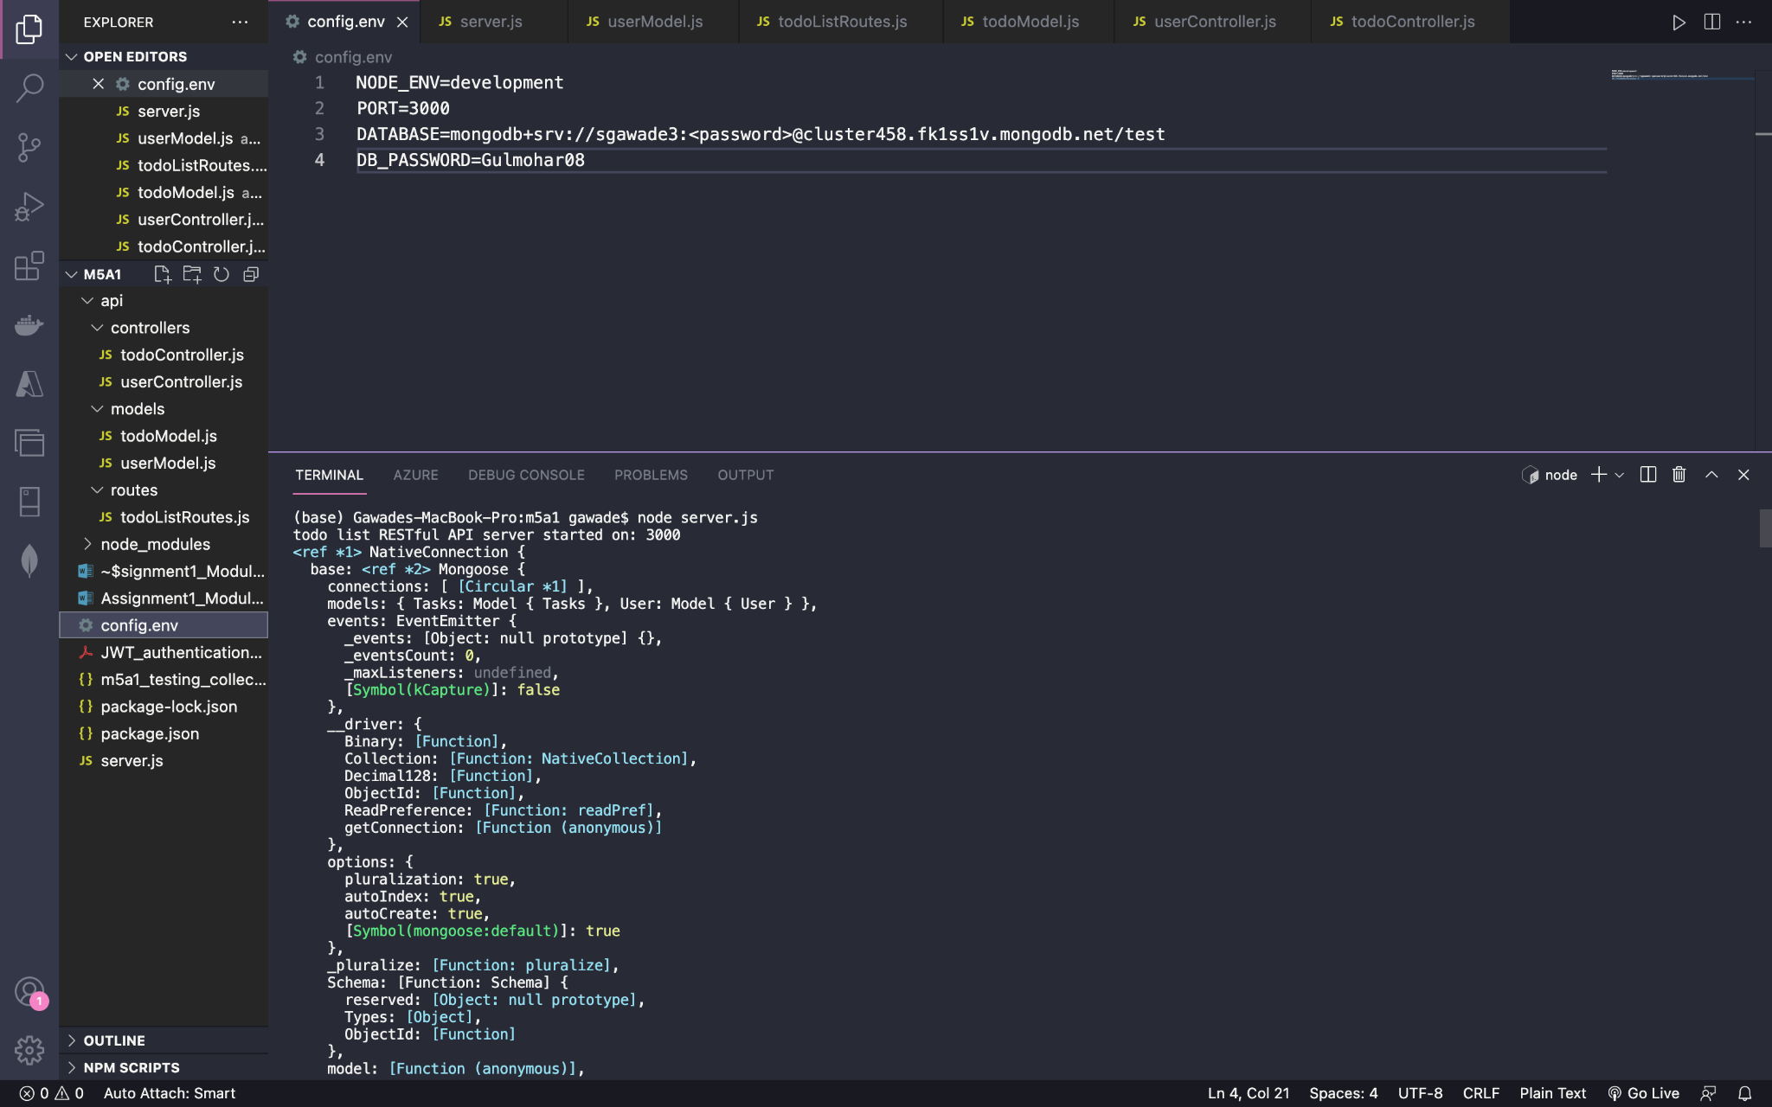

Testing in postman by sending a POST request and path localhost:3000/tasks

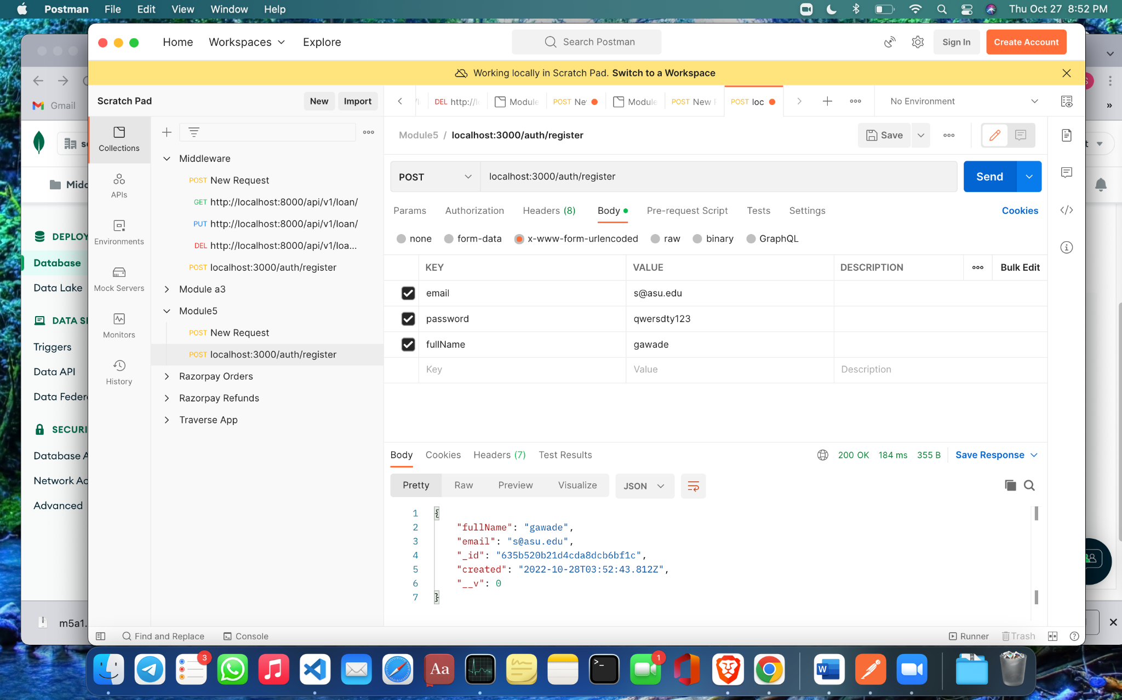

Creating a new user using postman by sending a POST request to localhost:3000/auth/register

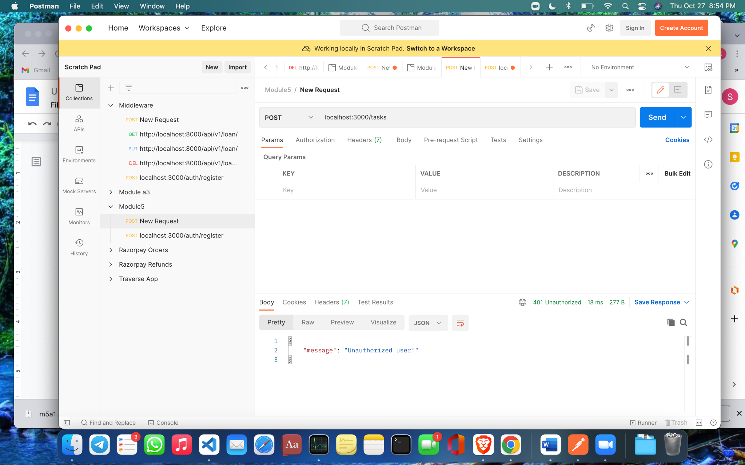

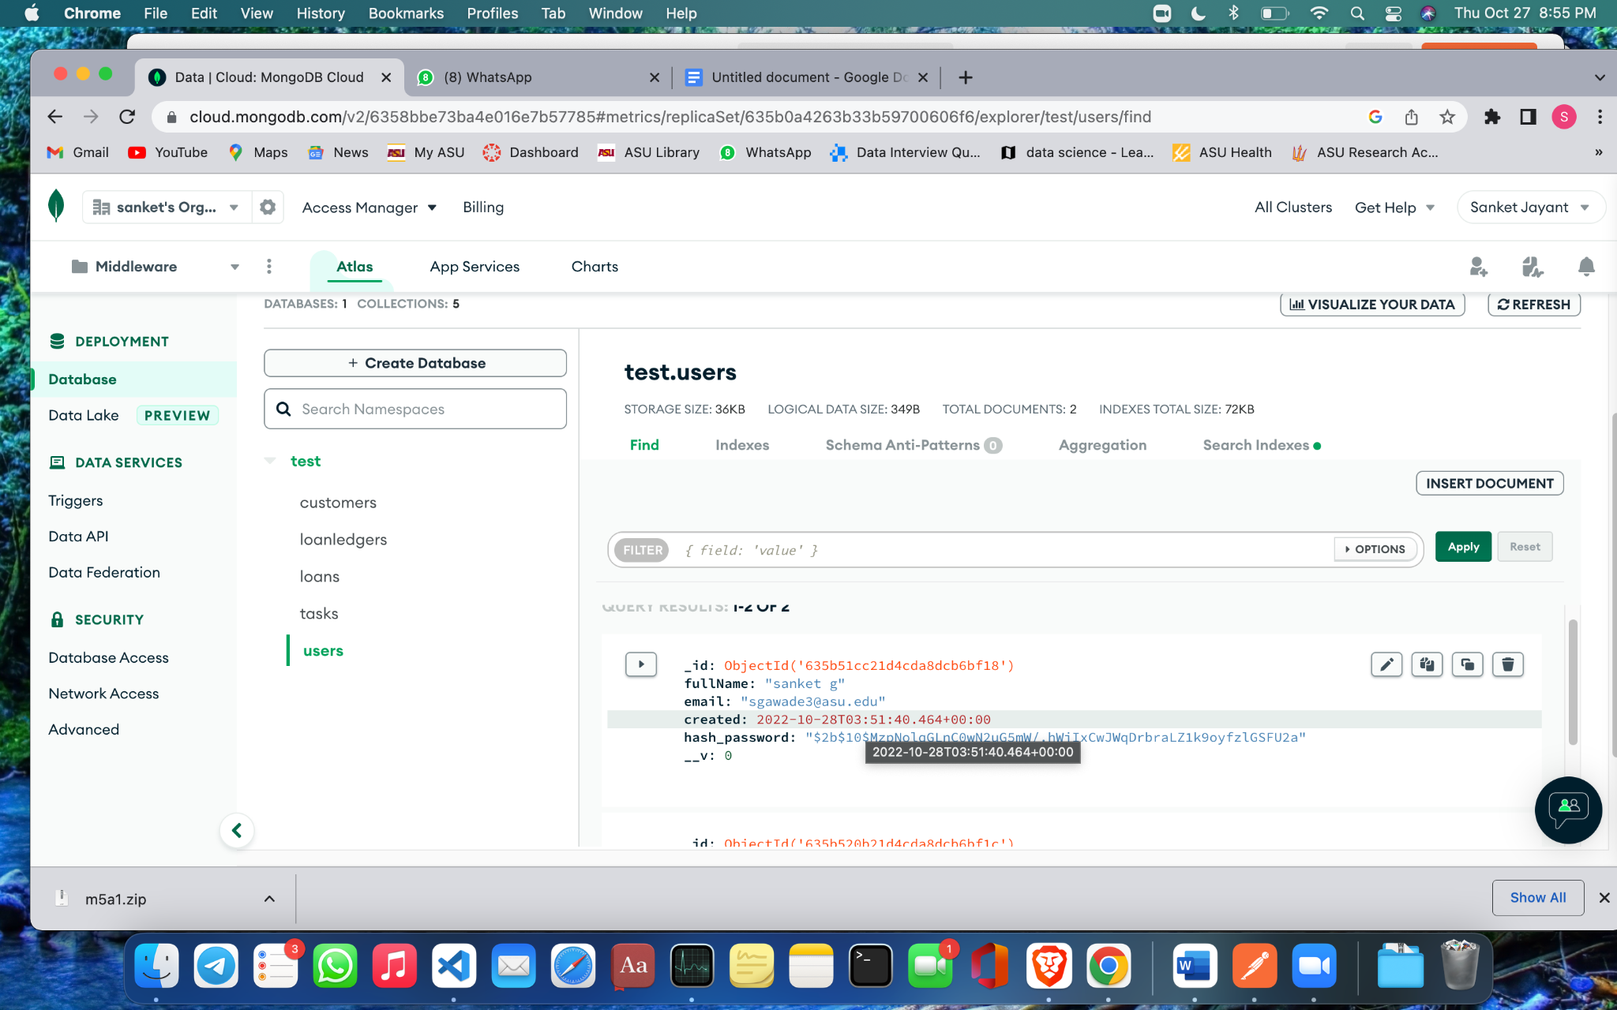

Signing in the user using their credentials in POST

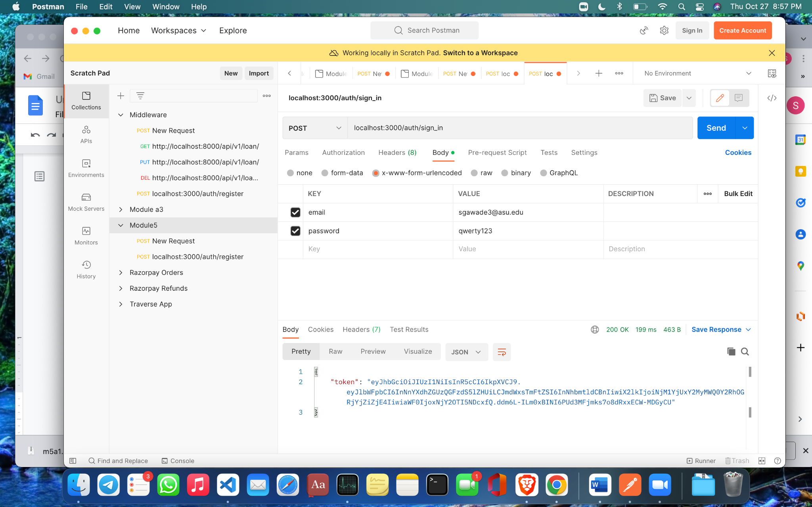

Testing the JWT token received by using it to add task in the task collection in MongoDB

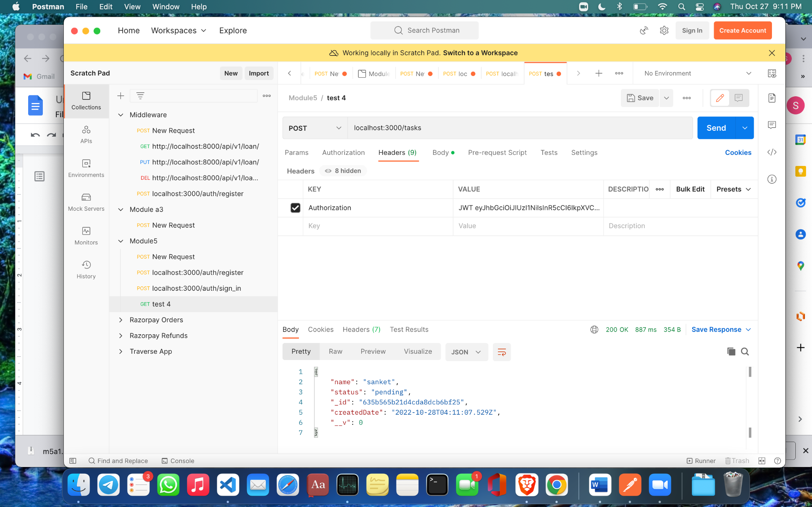

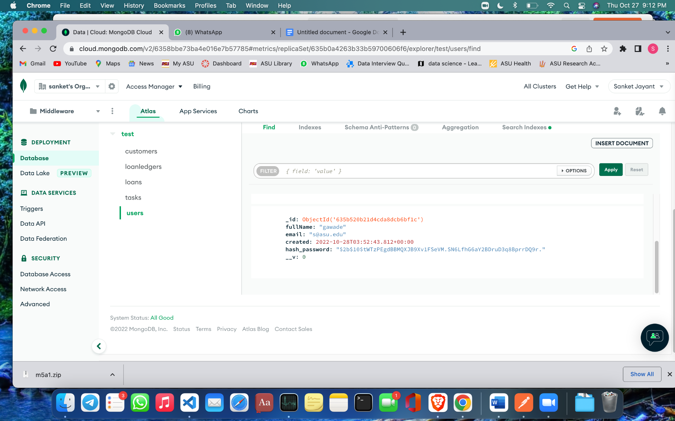

Screenshot of the collection generated in postman containing all the test cases, also saved in the submitted repository

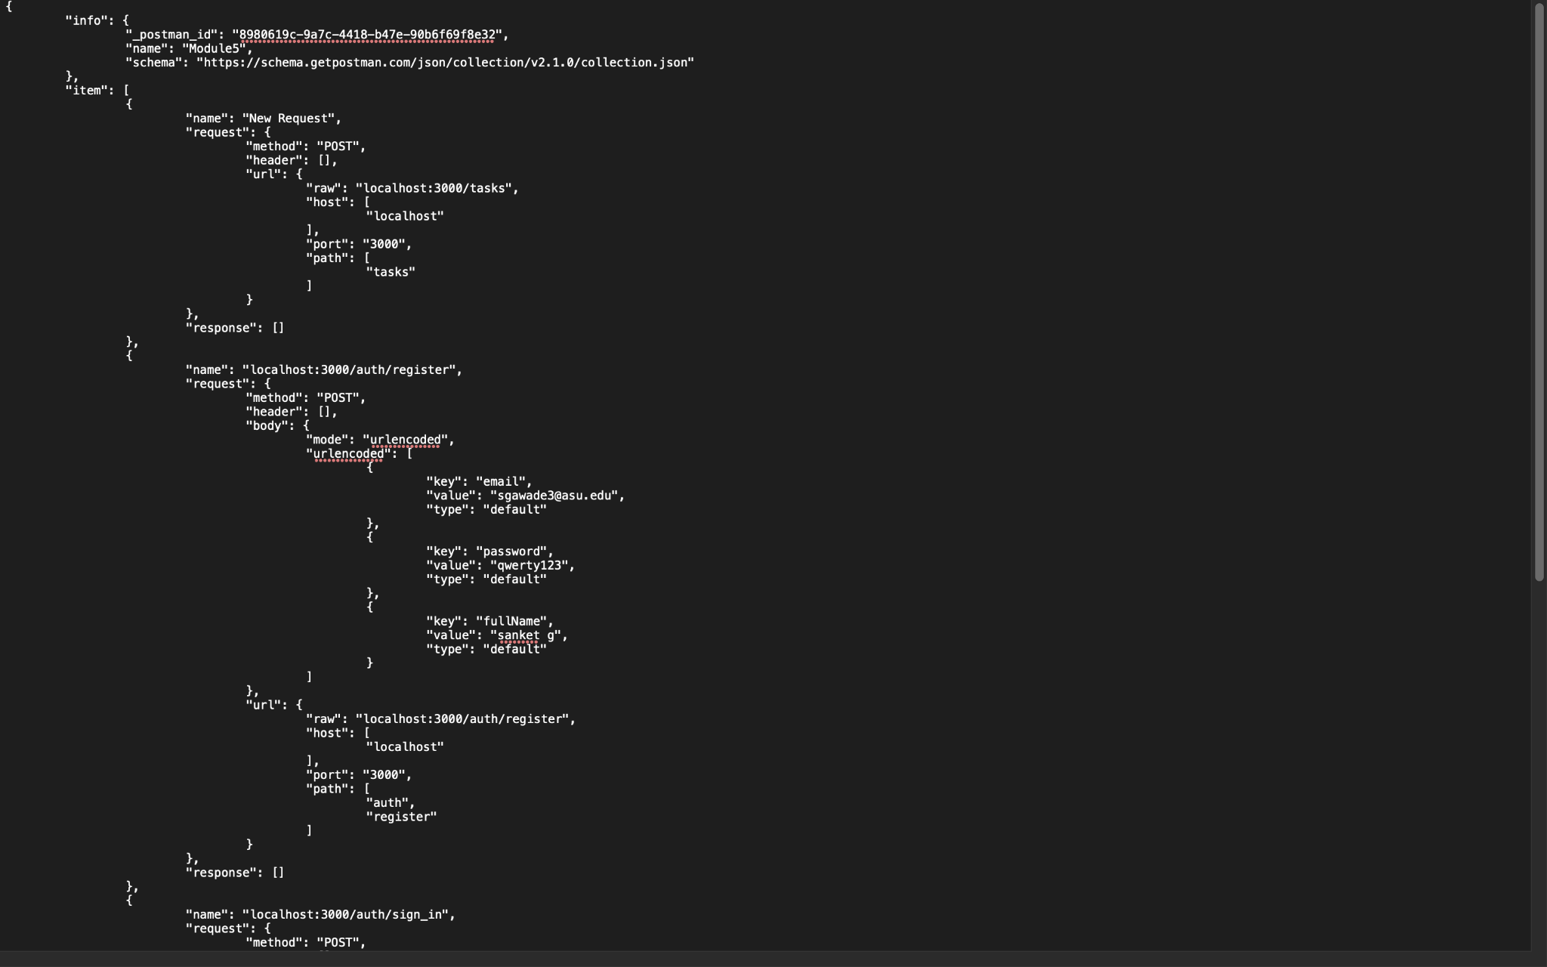

References

GitHub Link: